Seed Dispersal Activity Sheet
Activity 1
Look at each of the pictures below and see if you can decide how the seeds are dispersed in each of these cases. What adaptations can you see to help the process of dispersal in each one? This is a copy of an online activity in which you can click on the method to tell if you are correct http://www.countrysideinfo.co.uk/seed_dispersl/worksheet.htm
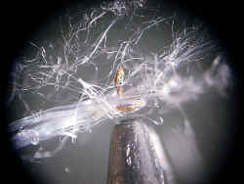 | 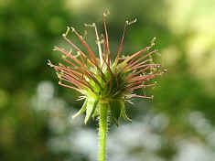 | 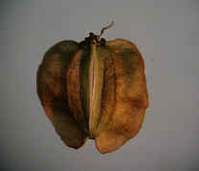
A (Note pencil tip for scale) | B | C (2mm long)
wind water animals explosive | wind water animals explosive | wind water animals explosive
Adaptations: | Adaptations: | Adaptations:
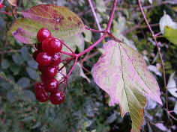 | 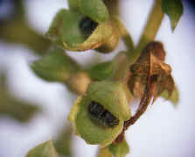 | 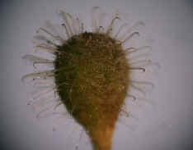
D | E | F
wind water animals explosive | wind water animals explosive | wind water animals explosive
Adaptations: | Adaptations: | Adaptations:

